**AS IS:**

目前TM官網的產品頁面如下

<http://www.tutorming.com/asp/products/product_introduction.asp>

**TO BE:**

1. 將以下banner的小字刪除, 只留”Fun Easy learning Chinese with TutorMing”, 且合併兩個banner結合並做成可切換的分頁模式

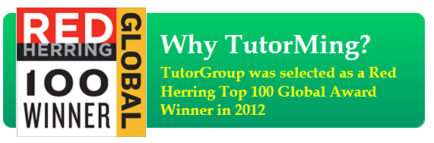

1. 產品頁面prototype如下, 強調A200並加入單堂課價錢/sessions數/期限, 排序為由大至小

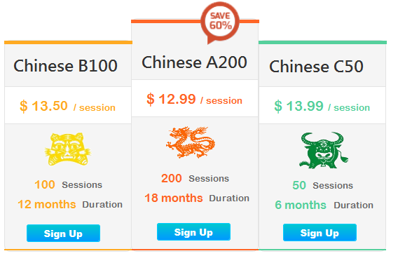

資訊如下

Chinese 200: $12.99/session – 200sessions – 18 months

Chinese 150: $13.5/session – 150sessions – 12 months

Chinese 100: $13.99/session - 100sessions – 12 months

Chinese 50: $14.99/session – 50sessions – 6 months

Chinese 30: $15.99/session – 30sessions – 3 months

Chinese 10: $16.9/session – 10sessions – 2 months

1. 最後加上對於課程的解說

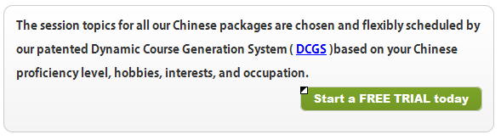

The session topics for all our Chinese packages are chosen and flexibly scheduled by our patented Dynamic Course Generation System ( [**DCGS**](http://www.tutorming.com/asp/products/tutorming.asp) ) based on your Chinese proficiency level, hobbies, interests, and occupation.